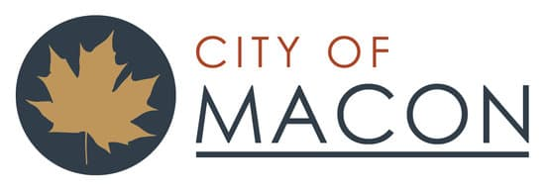

NEWS RELEASE

FOR IMMEDIATE RELEASE

Macon, Missouri – October 20, 2023 – The City of Macon and Macon Municipal Utilities want to make the citizens of Macon aware that the “Community Meeting” scheduled for October 24th, is not organized by, nor endorsed by the City or Macon Municipal Utilities. Neither the City nor Macon Municipal Utilities will be participating in the event in any official capacity. No person has been authorized to speak at the event on behalf of either entity.

The City Council and the Board of Macon Municipal Utilities have made significant progress in improving cooperation between the two entities, and that process remains ongoing. The City and Board have previously scheduled a joint work session later this month with Strategic Government Resources (SGR), a nationwide company that helps local governments be more successful. This workshop will be primarily focused on understanding the roles of both organizations.

The focus of both boards is on the important future projects that are going on in the city. Neither group sees particular value in discussing what may or may not have occurred in the past. Citizens who wish to know more about current projects and future plans are encouraged to call their council person or come to a City Council or Board of Public Works meeting.

The City Council meets the 2nd Tuesday of each month at 6:30 p.m. and the Board of Public Works holds their regularly scheduled meetings on the 3rd Monday of the month at 5 p.m. Both meetings are held in Council Chambers at City Hall and are open to the public.

